Joel Baby
Module 10.2 Assignment

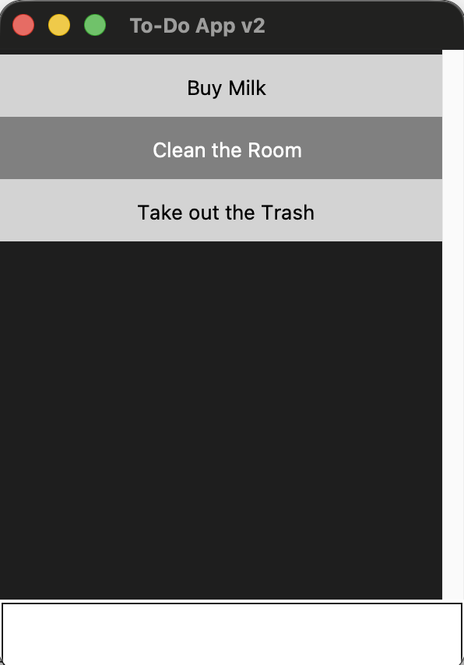

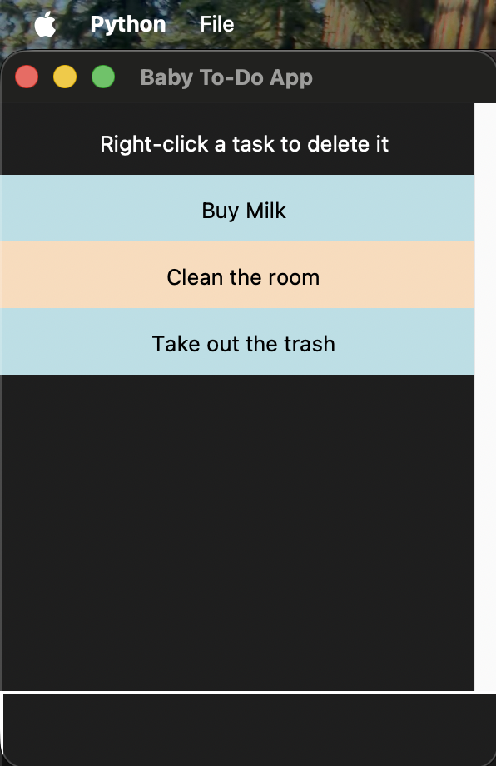
I’m using a MacBook so my file menu showing at the top instead with the app like the example.

